Exploratory analyses:

1. Analysis of empathy:

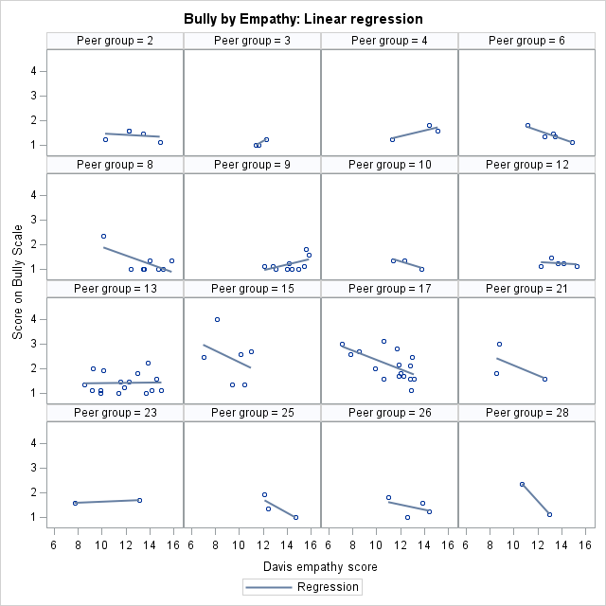

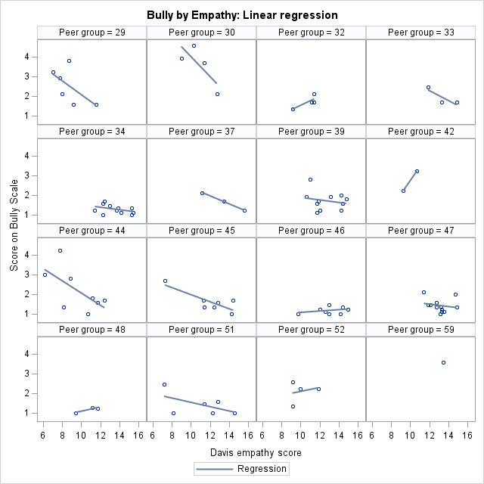

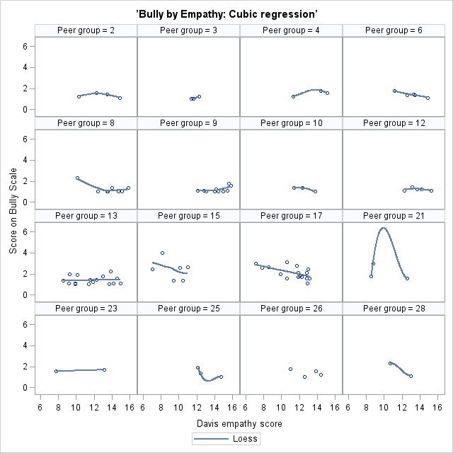

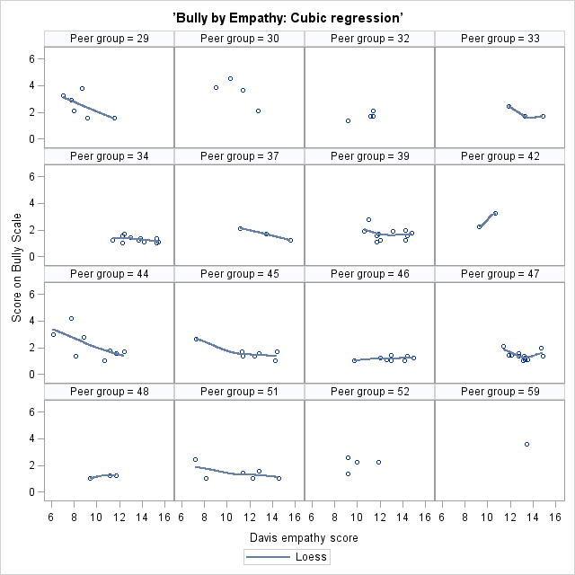

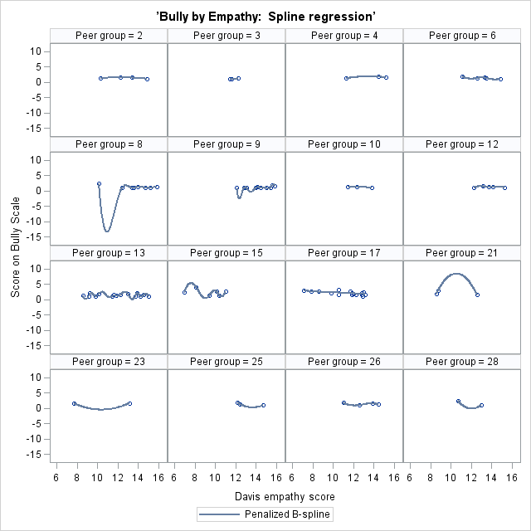

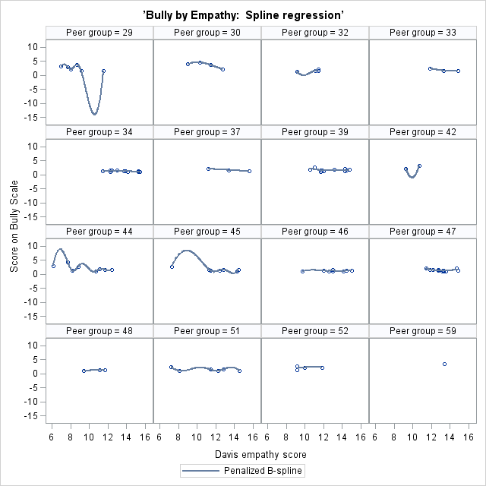

A sample of 32 peer groups was randomly selected. Based on the linear regression, cubic regression, and spline regression graphs of predicting bully by empathy, in general, there is a negative relationship between empathy and bully. Also, there are group differences in overall levels.

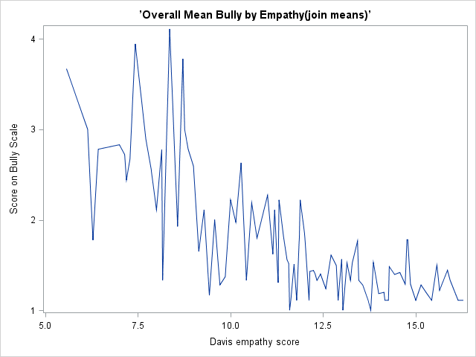

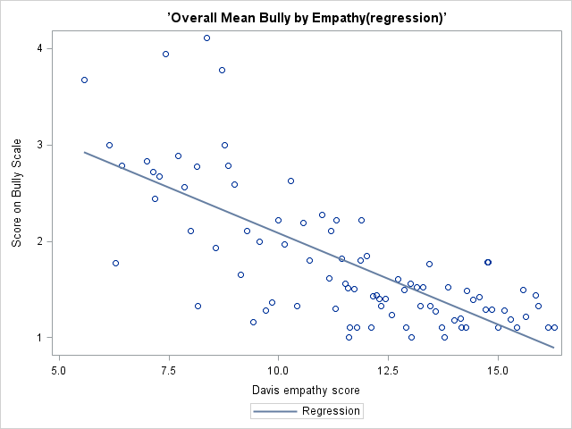

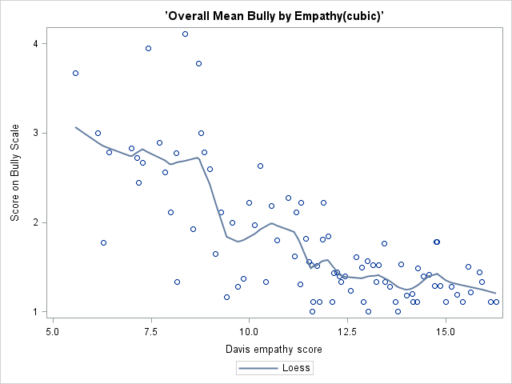

Based on the graphs of predicting bully by empathy using joined points, linear regression, and cubic regression, there is a negative relationship between empathy and bully.

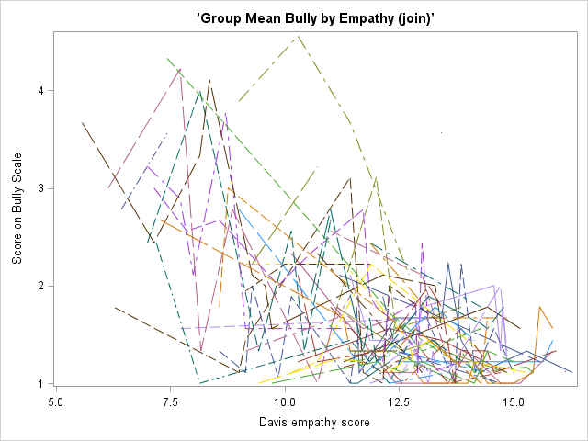

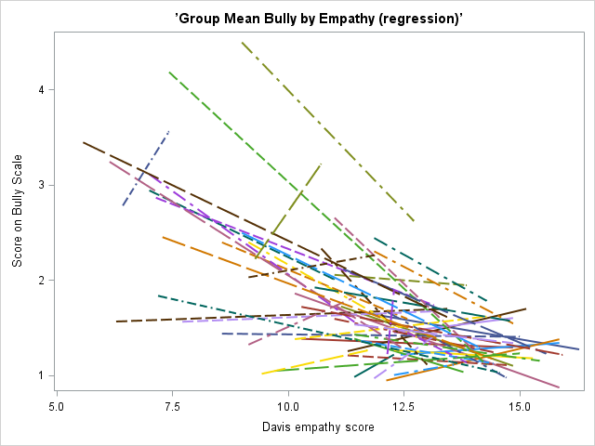

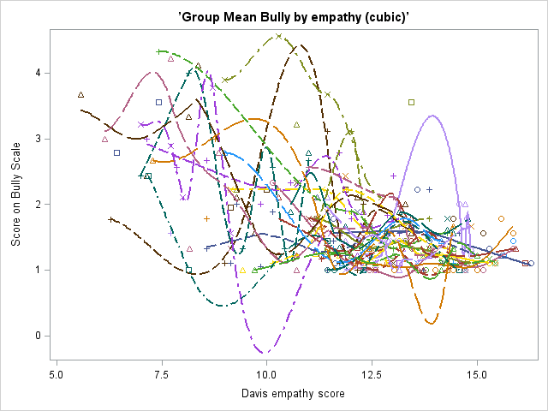

Based on the plots of predicting bully by empathy for each peer group in the same graph using joined points, linear regression, and cubic regression, there is a negative relationship between empathy and bully and group differences in the overall levels. Also, according to theses graphs, there are group differences in slope.

1. Analysis of fight:

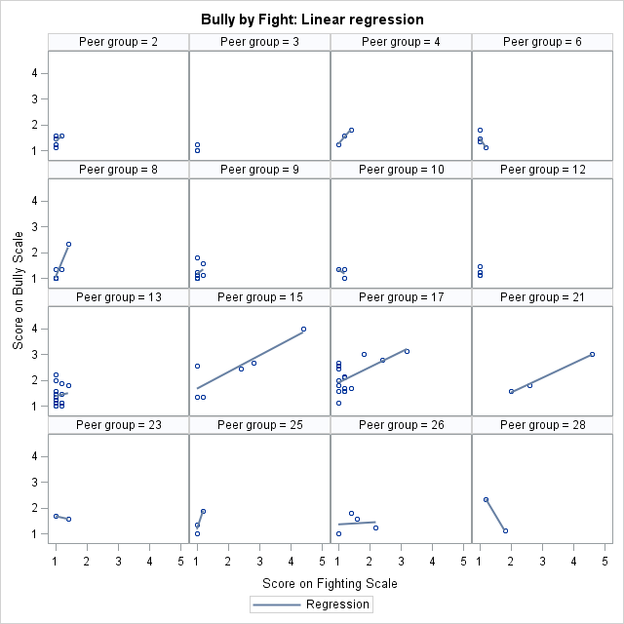

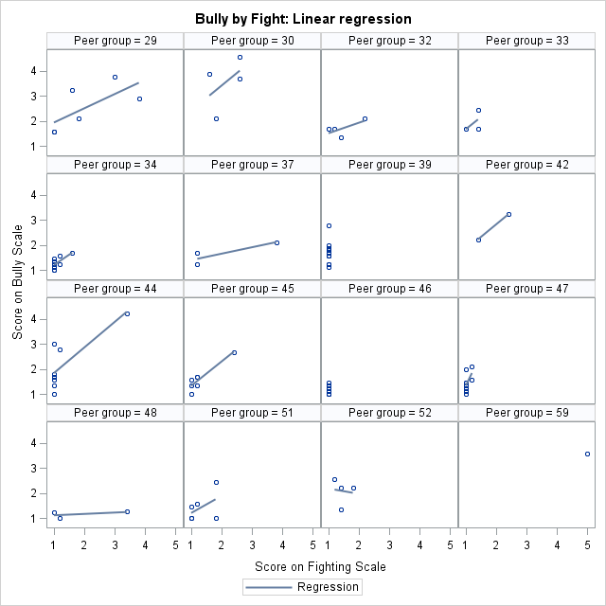

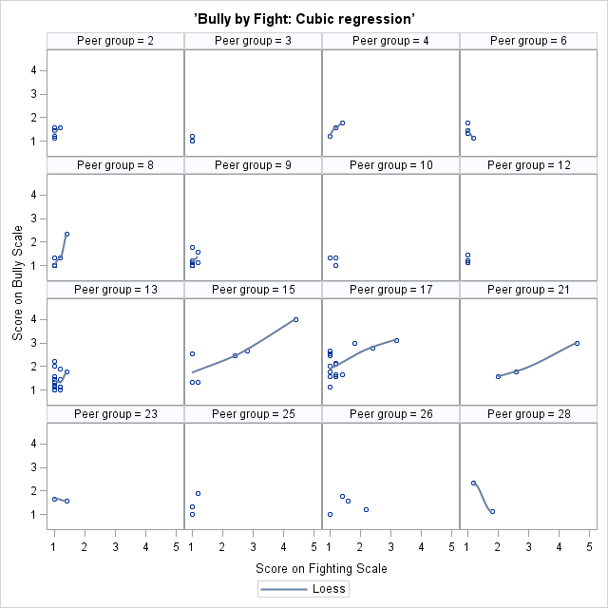

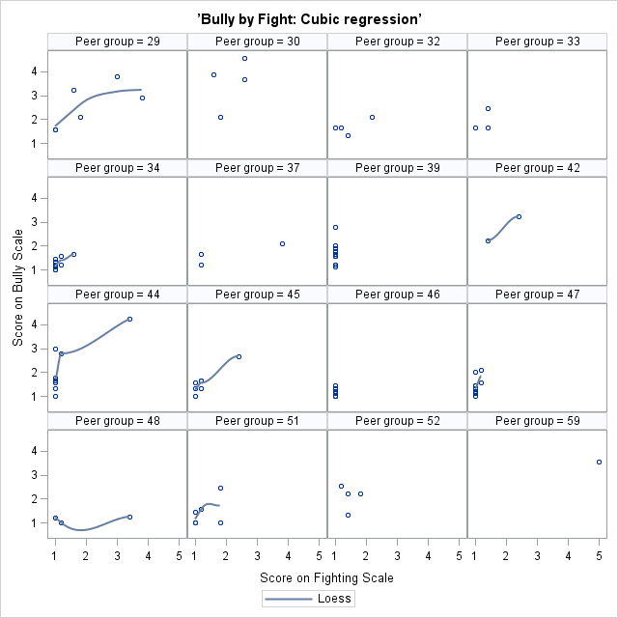

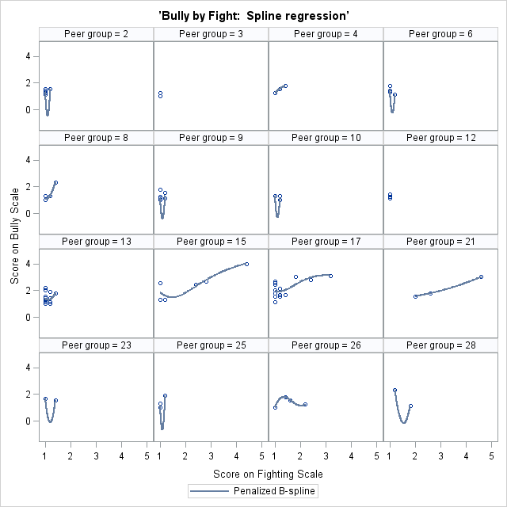

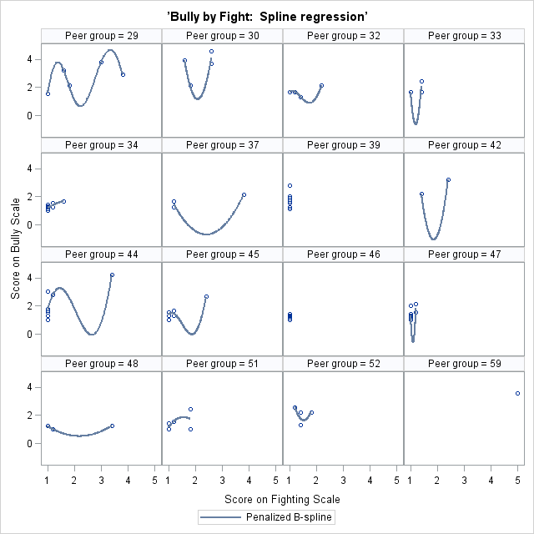

A sample of 32 peer groups was randomly selected. Based on the linear regression, cubic regression, and spline regression graphs of predicting bully by fight, in general, there is a positive relationship between fight and bully. Also, there are group differences in overall levels.

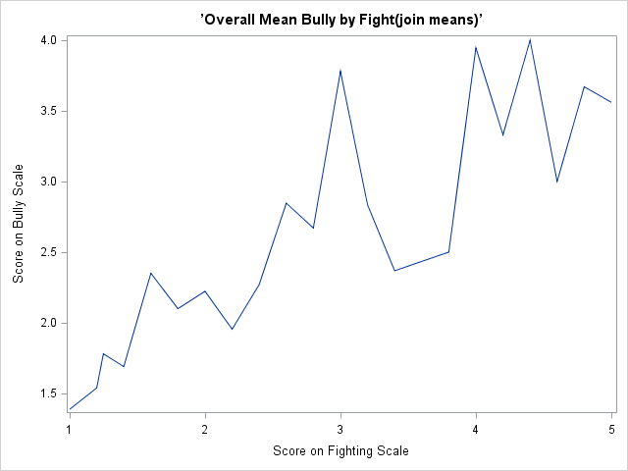

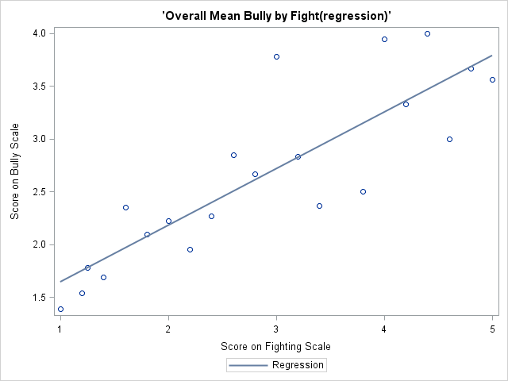

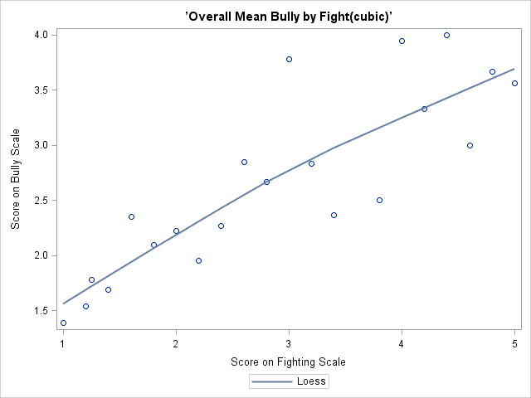

Based on the graphs of predicting bully by fight using joined points, linear regression, and cubic regression, there is a positive relationship between fight and bully.

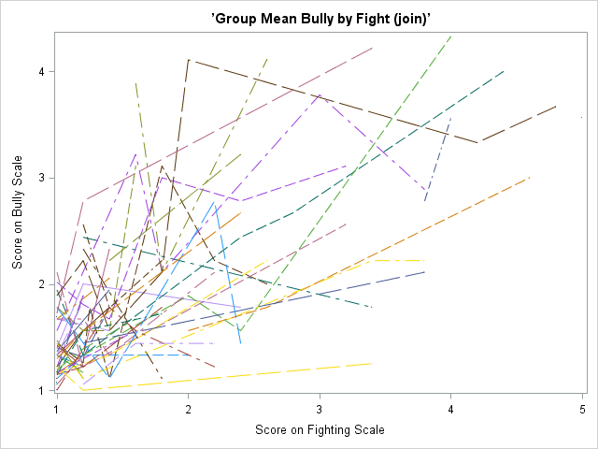

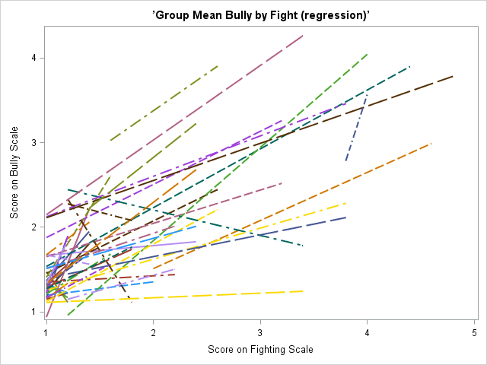

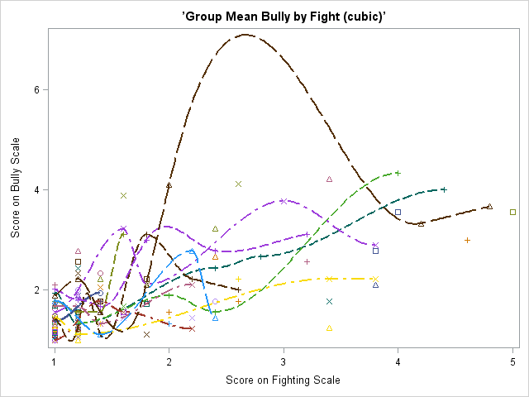

Based on the plots of predicting bully by fight for each peer group in the same graph using joined points, linear regression, and cubic regression, there is a positive relationship between fight and bully and group differences in the overall levels. Also, according to theses graphs, there are group differences in slope.

1. Analysis of gender:

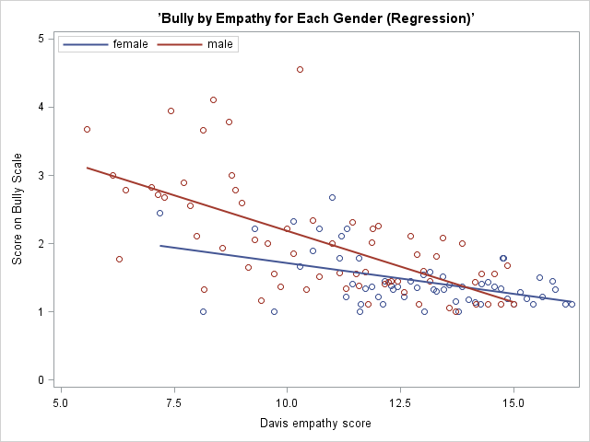

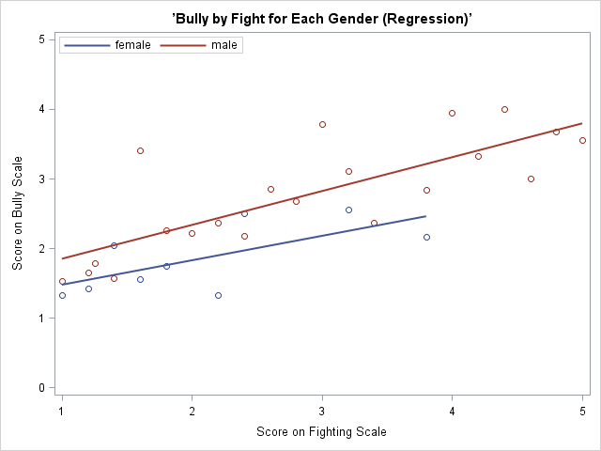

Based on the graphs of predicting by empathy and fight for each gender, there is an interaction between empathy and gender and a possible interaction between fight and gender.

Summary: Based on the exploratory analyses, there is a negative relationship between bully and empathy and a positive relationship between bully and fight. There is a possible random intercept. There is a possible random slope for empathy and a possible random slope for fight. Gender interacts with empathy and possibly also interacts with fight.

1. Testing for random slope: In order to test whether a random slope for fight, a random slope for empathy, or a random slope for both is needed, three models were tested. One model included a random slope for empathy, one included a random slope for fight, and one included random slopes for both. All models included gender, group-centered empathy, group-centered fight, and an interaction between gender and group-centered empathy as explanatory variables. Group mean empathy and group mean fight were used as explanatory variables for random intercept. The results of analyses indicated that the model included a random slope for empathy and the model included random slopes for both empathy and fight could not converge. Thus, only a random slope for fight was needed.

Model comparison:

The following models were fitted

Model 1: Random intercept model with no explanatory variables

(bully)ij = β0j + Rij

Β0j = γ00 + U0j

Rij ~ N (0, σ2) U0j ~ N (0, τ02)

Model 2: Full model

(bully)ij = β0j + β1j(grpCfight)ij + β2j(grpCempathy)ij + β3j(gender)ij + Rij

β0j = γ00 + γ01(grpMfight)j + γ02(grpMempathy)j + U0j

β1j = γ10 + γ11(gender)ij + γ12(grpMfight)j + U1j

β2j = γ20 + γ21(gender)ij

β3j = γ30

Rij ~ N (0, σ2) U0j ~ N (0, τ02) U1j ~ N (0, τ12)

Model 3: the full model with the interactions between empathy and gender, fight and gender removed.

(bully)ij = β0j + β1j(grpCfight)ij + β2j(grpCempathy)ij + β3j(gender)ij + Rij

β0j = γ00 + γ01(grpMfight)j + γ02(grpMempathy)j + U0j

β1j = γ10 + γ12(grpMfight)j + U1j

β2j = γ20

β3j = γ30

Rij ~ N (0, σ2) U0j ~ N (0, τ02) U1j ~ N (0, τ12)

Model 4: Model 3 with the main effect of gender removed.

(bully)ij = β0j + β1j(grpCfight)ij + β2j(grpCempathy)ij + Rij

β0j = γ00 + γ01(grpMfight)j + γ02(grpMempathy)j + U0j

β1j = γ10 + γ12(grpMfight)j + U1j

β2j = γ20

Rij ~ N (0, σ2) U0j ~ N (0, τ02) U1j ~ N (0, τ12)

Model 5: Model 4 with group mean fight removed as an explanatory variable for the random slope.

(bully)ij = β0j + β1j(grpCfight)ij + β2j(grpCempathy)ij + Rij

β0j = γ00 + γ01(grpMfight)j + γ02(grpMempathy)j + U0j

β1j = γ10 + U1j

β2j = γ20

Rij ~ N (0, σ2) U0j ~ N (0, τ02) U1j ~ N (0, τ12)

Model 6: Model 5 with the random effect for the slope removed.

(bully)ij = β0j + β1j(grpCfight)ij + β2j(grpCempathy)ij + Rij

β0j = γ00 + γ01(grpMfight)j + γ02(grpMempathy)j + U0j

β1j = γ10

β2j = γ20

Rij ~ N (0, σ2) U0j ~ N (0, τ02)

According to the analyses for the full model (Model 2), the effects of gender, the interactions of gender and group mean centered empathy, gender and group mean centered fight, and the interaction between group mean centered fight and group mean fight are all not significant. Therefore, likelihood ratio tests are used to further study these effects.

Model 1: For the null model, the intra-class correlation is 0.2046 / (0.2046+0.3051)=0.40. Thus, the correlation among individuals in the same peer group is pretty high, which implies that the null model doesn’t fit very well with the data.

Model 2 and Model 3: the p-value of the likelihood ratio test for the interaction terms of gender and group mean centered empathy, gender and group mean centered fight is 0.29314. The difference between the two models is not significant. Thus, the two interaction terms can be dropped.

Model 2 and Model 4: the p-value of the likelihood ratio test for the main effects of gender is 0.45093. The difference between the two models is not significant. Thus, gender can be dropped.

Model 2 and Model 5: the p-value of the likelihood ratio test for the effect of group mean fight as an explanatory variable for the random slope is 0.61549. The difference between the two models is not significant. Thus, group mean fight can be dropped as an explanatory variable for the random slope.

Based on the likelihood ratio tests above, the main effect of gender, the interactions terms of gender and group mean centered fight, gender and group mean centered empathy, and the effect of group mean fight as an explanatory variable for the random slope can all be dropped from the model. Finally, we need a test for the random slope.

Model 5 and Model 6: the p-value of the likelihood ratio for the random slope of fight is 0.014104 < 0.05. The difference between the two models is significant. Thus, a random slope for fight is necessary.

Based on the fit statistics (-2loglike, AIC, and BIC), in general, Model 5 has the smallest values and relatively fewer number of parameters.

Conclusion: Based on the fit statistics and likelihood ratio tests, Model 5 should be the best model:

Hierarchical Linear Model:

Level 1:

(bully)ij = β0j + β1j(grpCfight)ij + β2j(grpCempathy)ij + Rij

Level 2:

β0j = γ00 + γ01(grpMfight)j + γ02(grpMempathy)j + U0j

β1j = γ10 + U1j

β2j = γ20

Rij ~ N (0, σ2) U0j ~ N (0, τ02) U1j ~ N (0, τ12)

Linear Mixed Model:

(bully)ij = γ00 + γ01(grpMfight)j + γ02(grpMempathy)j + γ10(grpCfight)ij + U1j(grpCfight)ij + γ20(grpCempathy)ij + U0j + Rij

Marginal Model:

(bully)ij ~ N ((γ00 + γ01(grpMfight)j + γ02(grpMempathy)j + γ10(grpCfight)ij + γ20(grpCempathy)ij, (τ02 + 2τ10(grpCfight)ij + τ12(grpCfight)ij2 + σ2))

When plug in the numbers:

Level 1:

(bully)ij = β0j + β1j(grpCfight)ij + β2j(grpCempathy)ij + Rij

Level 2:

β0j = 2.2267+ 0.5104(grpMfight)j – 0.1074(grpMempathy)j + U0j

β1j = 0.4746+ U1j

β2j = -0.0775

Rij ~ N (0, 0.1638) U0j ~ N (0, 0.06615) U1j ~ N (0, 0.03425)

Linear Mixed Model:

(bully)ij = 2.2267+ 0.5104(grpMfight)j – 0.1074(grpMempathy)j + 0.4746(grpCfight)ij + U1j(grpCfight)ij – 0.0775(grpCempathy)ij + U0j + Rij

Marginal Model:

(bully)ij ~ N ((2.2267+ 0.5104(grpMfight)j – 0.1074(grpMempathy)j + 0.4746(grpCfight)ij – 0.0775(grpCempathy)ij, (0.06615 + 2(0.03591)(grpCfight)ij + 0.03425(grpCfight)ij2 + 0.1638))

Interpretation: When there is 1 unit increase in the group mean fight score, the individual’s bully score will increase by 0.5104. When there is 1 unit increase in the group mean empathy scores, the individual’s bully score will decrease by 0.1074. When the individual’s fight scores goes up by 1 unit compared to his or her group mean fight score, the individual’s bully scores will increase by 0.4746. When the individual’s empathy scores goes up by 1 unit compared to his or her group mean empathy score, the individual’s bully score will decrease by 0.0775.

Model diagnosis:

1. Normality of random effects

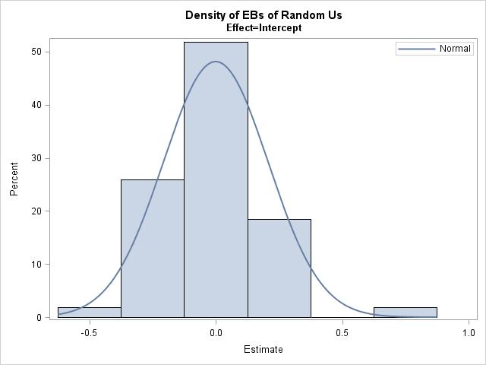

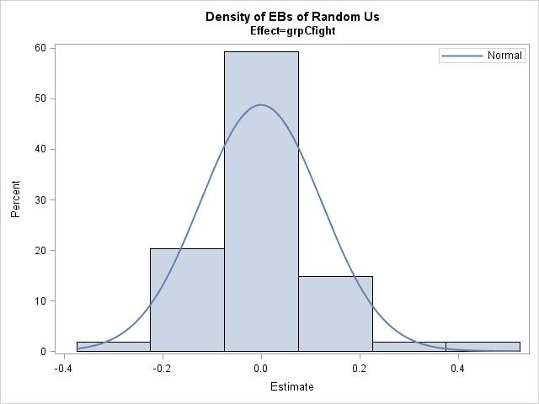

Based on the above graphs for normality, the distributions of the random intercept and random slope for group mean centered fight are generally normal.

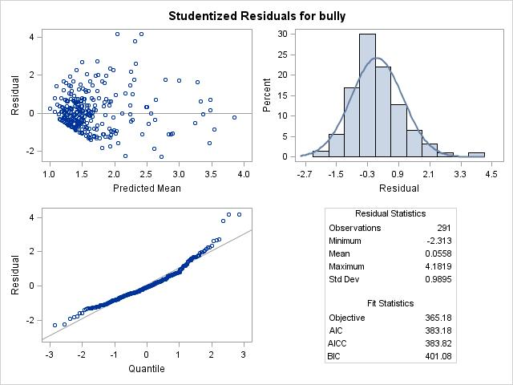

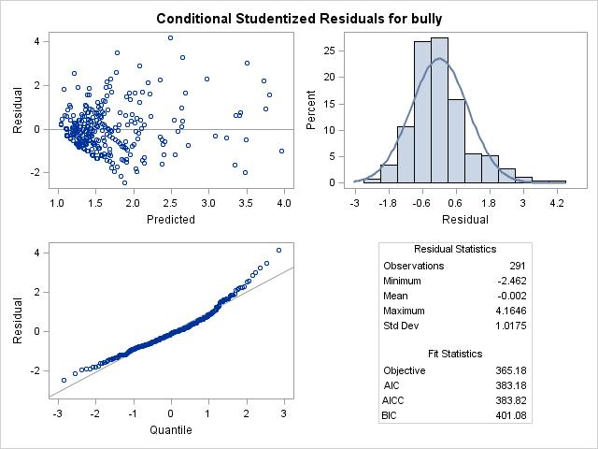

Above are studentized and conditional studentized residuals for bully. Based on the histograms, the distribution of the residuals might be normal. However, the QQ plots don’t indicate normality, especially at the lower and higher ends; while the residual vs. predicted mean plots show that those with smaller values on bully are more clustered than those with larger values.

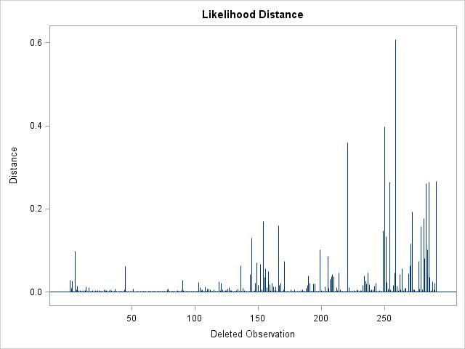

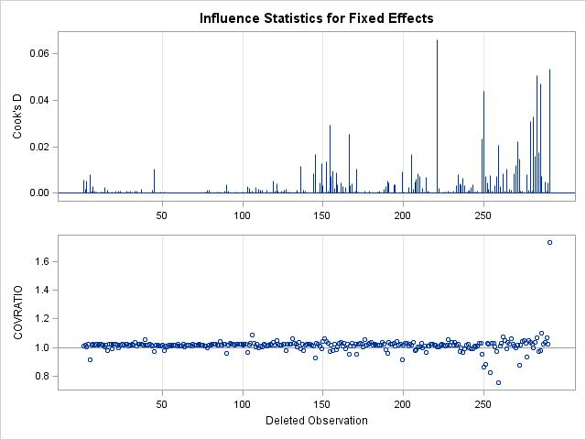

Based on the influence diagnosis graphs, there are some individuals that have a large influence on the effects of the model.

Question 1: Based on the analyses, the children will not differ on their bully scores in terms of their gender. However, their tendency to fight and empathy towards others do make a difference on bully scores. Specifically, when the individual’s fight score goes up by 1 unit compared to his or her group mean fight score, the individual’s bully scores will increase by 0.4746. When the individual’s empathy scores goes up by 1 unit compared his or her group mean empathy score, the individual’s bully score will decrease by 0.0775.

Question 2: There are differences on individuals’ bully scores depending on which peer groups they belong to. Specifically, if one is in a peer group with a high score on fight, his or her bully score tends to be higher. When there is 1 unit increase in the group mean fight score, the individual’s bully score will increase by 0.5104. If one is in a peer group with a high score on empathy, the his or her bully score tends to be lower. When there is 1 unit increase in the group mean empathy scores, the individual’s bully score will decrease by 0.1074